Lesson 5 – Activity Sheet

Getting Started

Healthy eating and exercise are an import part of children lives. You have been tasked with creating a digital quiz that asks students about what they eat. They answer a question or questions and the program tells them a score, a piece of advice or a food to eat.

**For example**:

Do you feel sleepy in the morning?

Button A = Yes

Button B = No

If the child presses Button A, then the micro:bit tells them they could eat more foods with iron.

Success Criteria

The product must:

* Have a display that the micro:bit is embedded in
* Be robust enough to be played with
* Contain a micro:bit that users can interact with
* Use the **buttons** to input answers
* Provide some feedback to the user, a score, some advice or a food to eat

**Some Ideas**

Here are some possible ideas that could be programmed:

* Provide instructions
* Ask the child a question, this could be on a sheet of paper or scrolled across the micro:bit
* Allow them to respond with Button A , B or A and B
* Record the answers (variables)
* Display a score at the end
* Use the overall score to provide a piece of advice
* Use an LED to flash if a certain score is reached

Try out some of online health quizzes to get an idea what type of questions are asked.

**Design**

Create a display box for your micro:bit to sit in that will attract children to come up and try out the quiz. Remember to be creative and colourful as the product needs appeal to children as well as being easy to use. Think about the questions that you want to ask and also how you will ask them? Will they be displayed across the micro:bit or as a list on paper?

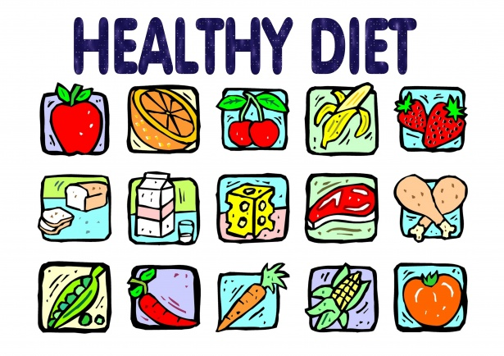

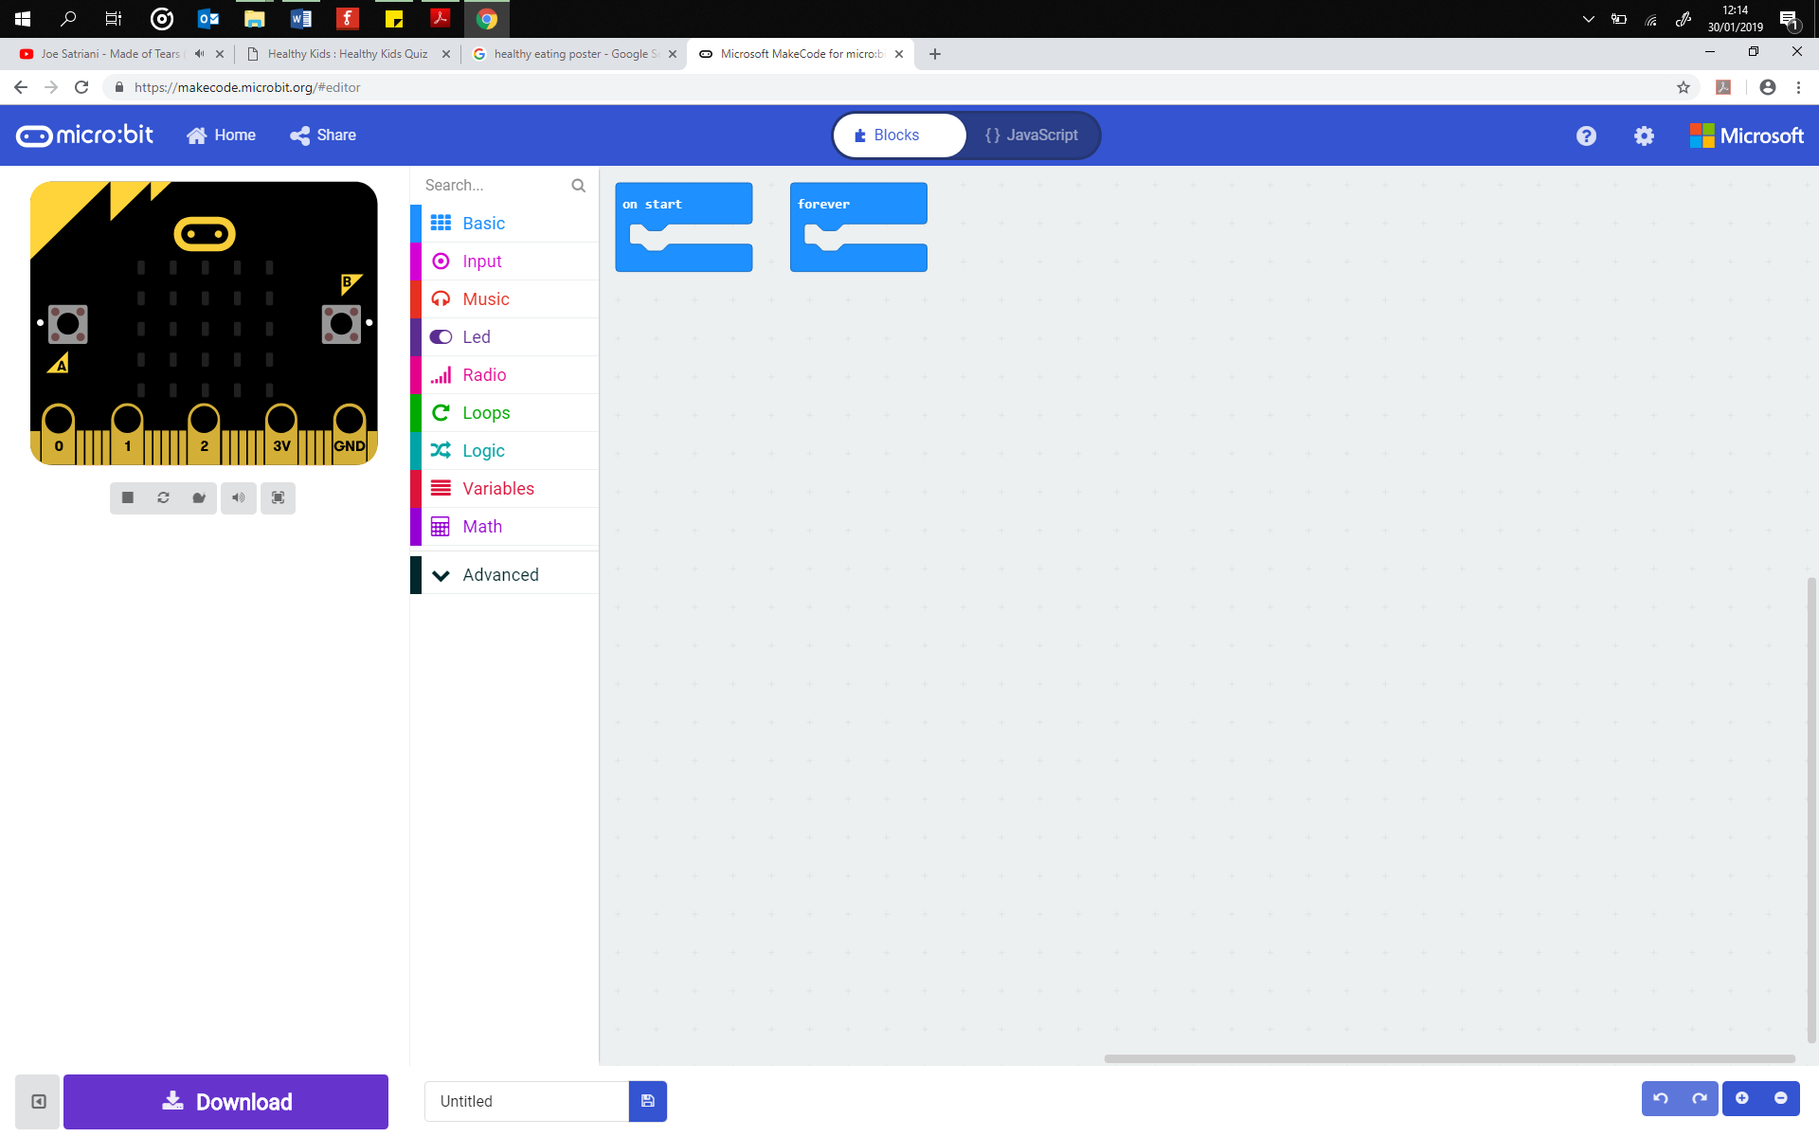

## **Materials Needed**

## Think about the materials that you need to create this. A cardboard box, paper, paints. Remember that it needs to appeal to young children.

## Pro-tip

Plan the questions, answers and responses first before you start building your program. This will support you to use the correct selection code and responses.

*Question 1 – Do you drink more than two cans of pop a day?*

*A = Yes B = No*

*Response A = Sad face*

*Response B = Smile*

## Test Time

Download your programs to your micro:bit and test them. Ensure that the program responds as you expect it to. Ask some children to try out the program and suggest improvements and changes. Remember to also test the design of the box. Is it child friendly? Does it appeal to them? Is it simple enough for a child to use?

## Stretch Tasks

* Add images to the quiz
* Create images of the food that the child could eat
* Use LEDs on the box to attract children to come and look at the box
* Wire up LEDs as indicators of the outcome of the quiz

## Final Thoughts

In this project you are making a healthy eating quiz for young children. It should be child friendly, fun and appeal to them. The program should also give the child some sort of feedback, such as advice or a score.